RFM Customer Segmentation with Python, SQL & Power BI

Preparer: Yunus Ahmet DOKAZOĞLU

TABLE OF CONTENTS
- Introduction
1.1 Project Objective
1.2 What is RFM Analysis?
1.3 Business Motivation and Technological Tools
- Dataset Overview
2.1 Data Source
2.2 Data Structure
2.3 Variable Definitions
- Data Preprocessing (Python)
3.1 Data Loading and Column Renaming
3.2 Handling Missing and Invalid Data
3.3 Data Type Conversions
3.4 Python Codes
- Database Operations (SQL)
4.1 Database Structure and Table Design
4.2 Data Import and Validation
4.3 SQL Queries for RFM Calculation
4.4 Segmentation Queries
4.5 SQL Workflow
- RFM Analysis and Segmentation
5.1 Recency, Frequency, Monetary Concepts
5.2 Calculation of RFM Scores
5.3 Defining Customer Segments
5.4 Interpretation of RFM Results
- Results and Discussion
6.1 Summary of Findings
6.2 Key Takeaways
6.3 Recommendations and Future Work
- Conclusion Summary

1. INTRODUCTION
1.1 Purpose of the Project
This project was developed to gain a deeper understanding of customer behavior and to support data-driven marketing strategies. In today’s competitive environment, businesses rely heavily on customer analytics to sustain long-term relationships and increase revenue. However, analyzing data effectively requires more than generating sales reports — it involves identifying customers according to their overall value to the company.
With this in mind, the project focuses on performing RFM (Recency, Frequency, Monetary) analysis using real sales data. The dataset used in this study originates from the Online Retail II dataset, which contains actual sales transactions from an e-commerce company between 2009 and 2011. The data includes invoice numbers, product codes, quantities, prices, customer IDs, and countries, covering nearly half a million records. Using a real-world dataset adds credibility and ensures that the results reflect realistic business scenarios.
The main objective is to analyze customer purchasing behavior statistically and to categorize them based on how recently, how often, and how much they purchase. Through this analysis, businesses can answer key questions such as:
- Which customers are the most loyal and frequent buyers?
- Which customers are at risk of churning?
- Which segments generate the highest revenue potential?
- Which customer groups should be re-targeted for marketing campaigns?
Beyond its analytical focus, this project also serves as a practical portfolio case that integrates data science, statistics, and marketing analytics. Throughout the process, both Python and SQL were used collaboratively — enabling data cleaning, transformation, scoring, and segmentation within a complete data pipeline.
In summary, this study presents a data-driven model that can be adapted for real business environments and used as part of a company’s decision-support and customer relationship management systems.

1.2 What is RFM Analysis?
RFM analysis is a well-established technique used for customer segmentation. It evaluates customers based on three key behavioral dimensions:
- Recency: How recently the customer made their last purchase.
- Frequency: How often the customer makes purchases within a defined period.
- Monetary: The total amount the customer has spent.
By combining these three metrics, an RFM score is calculated for each customer — typically ranging from 1 to 5 for each dimension. A higher score represents a more valuable customer. For example, a “555” score indicates a highly loyal, frequent, and high-spending customer, while a “111” score reflects customers who are inactive, infrequent, and contribute little to total revenue.
Even though RFM analysis is based on past transactions, it provides a strong foundation for predicting future purchasing behavior. Customers who have purchased frequently and spent more in the past are statistically more likely to continue doing so. For this reason, RFM is widely used in marketing to identify target audiences, create personalized offers, and develop loyalty programs.
Another key advantage of RFM is its simplicity and interpretability compared to more complex machine learning models. The RFM score can also be used as an input for predictive modeling, such as Customer Lifetime Value (CLV) estimation or churn prediction, making it a versatile component of customer analytics.

1.3 Tools and Technologies Used
This project was built upon two primary technologies: Python and SQL Server.
- Python: As one of the most popular tools for data analytics, Python was used for data preprocessing, cleaning, transformation, and initial analysis. The pandas library was employed for data manipulation, numpy for numerical operations, and datetime for handling date-related calculations. During preprocessing, missing, duplicate, and inconsistent values were identified and corrected to ensure data integrity.
- SQL Server: After data preparation in Python, the dataset was imported into SQL Server for analytical querying. SQL was used to calculate RFM scores and segment customers efficiently through statements such as GROUP BY, CASE WHEN, DATEDIFF, and JOIN. SQL’s ability to handle large datasets and perform structured analysis made it an ideal choice for this stage.
By integrating Python and SQL, the project followed an end-to-end ETL (Extract, Transform, Load) process:
data was cleaned and transformed in Python, then loaded into SQL for modeling and querying. This workflow mirrors how professional data analysts operate in real business settings, combining programming and database management skills.
Overall, this project not only demonstrates the practical implementation of the RFM model but also showcases the end-to-end data analytics process, including data cleaning, transformation, querying, and interpretation. It highlights the analytical thinking and technical capabilities expected from a professional data analyst.

2. DATASET OVERVIEW
2.1 Source of the Dataset
The dataset used in this project is known as Online Retail II (2009–2011) and is publicly available through the UCI Machine Learning Repository. It contains real transactional data from an online retail company based in the United Kingdom, covering the period between December 1, 2009, and December 9, 2011.
The Online Retail II dataset is widely used in both academic and industrial data analytics projects. Because it originates from real-world operations, it provides a reliable and meaningful basis for studying customer behavior, sales performance, and business insights. This dataset is commonly applied in customer segmentation, RFM analysis, purchase tendency modeling, and Customer Lifetime Value (CLV) estimation.
One of the key strengths of this project is that it relies on authentic sales data, not synthetic or simulated samples. Therefore, the findings are not only theoretical but also reflect realistic business cases.
The dataset is provided in Excel format (.xlsx) with two separate sheets:
- Year 2009–2010
- Year 2010–2011
Both sheets share the same structure, differing only in date range. For consistency, these two sheets were merged into a single comprehensive dataset before analysis.

2.2 Dataset Structure
The dataset consists of approximately 541,909 rows and 8 columns. Each row represents a single transaction (invoice-level record). The columns are defined as follows:
Column Name | Meaning | Description
Invoice | Invoice Number | A unique identifier for each transaction. Invoices beginning with “C” indicate canceled (returned) orders.
StockCode | Product Code | A unique code representing the sold item.
Description | Product Description | The name or short description of the product.
Quantity | Quantity | The number of items purchased in the transaction.
InvoiceDate | Invoice Date | The date and time of the transaction.
Price | Unit Price | The price per unit of the product (in GBP).
Customer ID | Customer Identifier | A unique ID for the customer who made the purchase.
Country | Country | The country of the customer.

These variables contain all the essential components required for performing an RFM analysis.
- Recency is derived from the “InvoiceDate,”
- Frequency is calculated using “Invoice” and “Customer ID,”
- Monetary is computed based on “Quantity” and “Price.”
The dataset supports analysis at both the individual customer and country levels. Because the “InvoiceDate” column includes timestamps, it can also be used for time-based analysis such as monthly or weekly purchase trends.
2.3 Variable Definitions and Data Characteristics
The dataset contains different variable types and required preprocessing before analysis. For example:
- The Quantity and Price columns include negative values, which represent product returns or cancellations. These records were excluded from analysis.
- The Customer ID column contains missing (NaN) values. Transactions without valid customer IDs were also excluded from the RFM analysis.
- The InvoiceDate column was converted into the proper datetime format for accurate recency calculations.
After cleaning, the total number of valid records was reduced to approximately 400,000, keeping only positive transactions with valid customer identifiers.
All monetary values were kept in GBP (British Pounds) to preserve data accuracy. The dataset includes customers from 38 different countries, with the United Kingdom representing nearly 90% of total transactions.
From a geographical perspective, most transactions come from European countries, but there are also customers from regions such as Australia, Japan, and the United States — making the dataset valuable for international customer analysis.
2.4 Data Quality and Preprocessing Steps
Before conducting the RFM analysis, a series of quality control and preprocessing steps were performed:
- Handling missing values: Records with missing “Customer ID” were removed.
- Outlier detection: Negative or zero values in “Quantity” and “Price” were filtered out as they represented returns or invalid transactions.
- Duplicate checking: Repeated records with the same invoice and product code were identified and handled.
- Date formatting: “InvoiceDate” values were standardized to ensure consistent date-time structure.
These steps were carried out using Python’s pandas library. As a result, a clean, structured dataset suitable for analysis was obtained. Proper preprocessing is crucial for RFM accuracy — even minor data errors can distort the recency, frequency, or monetary calculations for each customer.

2.5 Suitability of the Dataset for Analysis
The Online Retail II dataset is particularly suitable for customer-level analysis because it is organized at the customer–invoice–product level. This allows detailed exploration of purchasing patterns and segmentation by behavior. The two-year time range provides enough temporal variation to study changes in customer activity over time.
This structure enables not only RFM segmentation but also the development of advanced analytical models such as Customer Lifetime Value (CLV) prediction, churn analysis, and targeted marketing segmentation.
In short, this dataset is considered an ideal foundation for real-world data analysis projects, offering both scale and complexity while remaining clean and interpretable enough for meaningful business insights.

3. DATA PREPROCESSING (PYTHON)
3.1 Data Loading and Column Renaming
Data preprocessing is one of the most critical stages in any data analytics project. Raw data often contains missing, inconsistent, or unstructured values. Therefore, it must be transformed into a clean and usable format before performing any analysis.
In this project, the preprocessing steps were carried out using the Python programming language. Its flexibility and rich library ecosystem made it ideal for reading, cleaning, and transforming the dataset.
The Online Retail II (2009–2011) dataset was provided in .xlsx format, consisting of two separate sheets.

Both were loaded using the pandas library and then combined into a single DataFrame.
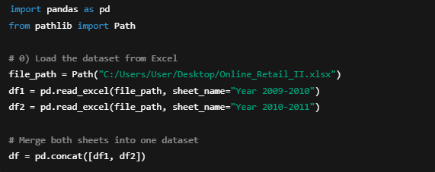
After loading, the column names were originally in English and were kept as is, but to improve readability and consistency during analysis, custom mappings were also defined when needed. Renaming columns helps analysts quickly understand the meaning of each variable.
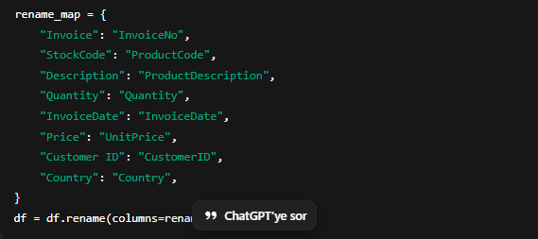
At this stage, the dataset became ready for cleaning and transformation steps before the RFM analysis.

3.2 Handling Missing and Invalid Data
Since the Online Retail II dataset contains real-world transactional data, it naturally includes some inconsistencies such as missing customer IDs, canceled invoices, and negative quantities. These records must be handled properly to avoid distorting the analysis.

The following cleaning operations were applied:
- Removing missing customer IDs:
Transactions with no customer identification cannot be associated with any RFM calculation.

- Filtering negative or zero quantities:
Negative quantities indicate product returns or cancellations. Such records were excluded from the dataset.

- Filtering invalid prices:
Transactions with zero or negative prices were also removed.

- Removing duplicate rows:
Duplicate transactions were checked and removed based on identical invoice, product, and customer IDs.

After these steps, the dataset retained only valid and meaningful sales records, ensuring a clean foundation for further analysis.

3.3 Data Type Conversions and Derived Variables
To ensure consistent analysis, variable types were converted into proper formats. In particular, date, numeric, and string columns were standardized as shown below:
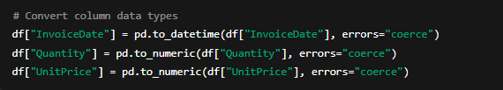
A new derived variable was also created:
TotalAmount = Quantity × UnitPrice
This variable represents the total transaction value for each record and forms the basis for the Monetary component of the RFM model.
After these transformations, the dataset became fully structured and suitable for customer-level aggregation and RFM scoring.

3.4 Preparing the Dataset for RFM Analysis
RFM analysis is based on three key behavioral indicators of a customer — Recency, Frequency, and Monetary.
To calculate these metrics, the dataset was grouped by customer, and the latest transaction date was used to compute the number of days since their last purchase.
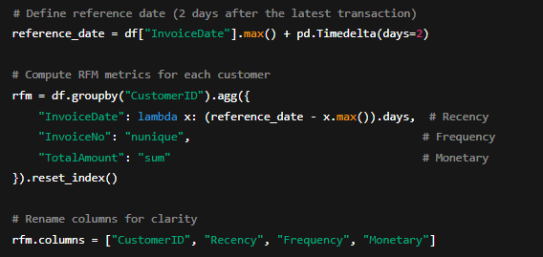
This aggregation generated three core variables for each customer:
- Recency: Number of days since the customer’s last purchase.
- Frequency: Total number of unique transactions (invoices).
- Monetary: Total spending value by the customer.
These values serve as the foundation for the RFM scoring system, which will later be used for customer segmentation.

3.5 Importance of Data Preprocessing
Data preprocessing is a crucial part of the entire analytical pipeline. Without cleaning and standardizing the dataset, the accuracy of RFM scoring can be severely compromised. For example:
- Customers with missing IDs may create duplicate entries,
- Returned items might incorrectly inflate sales totals,
- Date inconsistencies could distort the recency calculation.
Using Python ensured that all data preparation steps were automated, transparent, and reproducible. The use of libraries such as pandas made it possible to handle hundreds of thousands of rows efficiently.
As a result, a clean, standardized dataset was obtained — fully ready for RFM scoring and segmentation within the SQL environment in the next stage of the project.
4. DATABASE OPERATIONS (SQL)
4.1 Database Structure and Table Design
After the dataset was cleaned and prepared in Python, the next step was to transfer it into the SQL Server environment. This allowed analytical operations and RFM calculations to be executed more efficiently while maintaining data integrity.
The goal at this stage was to create a structured and well-organized database for RFM computations. The process was completed using SQL Server Management Studio (SSMS) through the following steps:
- Creating a new database:
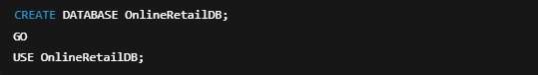
- Designing the main table structure:
The data exported from Python was stored in a table with the following schema:
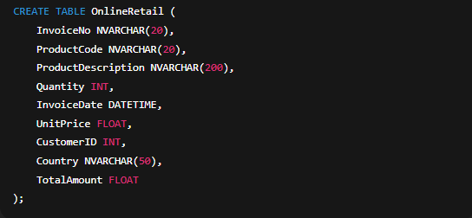
- Importing data:
The cleaned dataset from Python was exported as .csv or .xlsx and loaded into the SQL table using the SQL Server Import and Export Wizard.
This setup ensured that each record maintained structural consistency between Python and SQL environments, enabling seamless integration across both platforms.

4.2 Data Import Validation and Quality Checks
Once the data was loaded into SQL Server, several validation queries were executed to verify accuracy and consistency:
- Total record count:
- Checking for missing customer IDs:
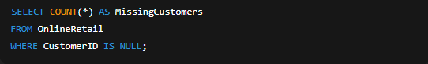
- Checking for negative quantities or prices:
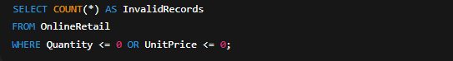
- Checking for missing product descriptions:
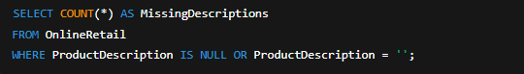
These validation steps confirmed that the SQL dataset was consistent with the cleaned Python version. If discrepancies were found, SQL-level corrections were applied to maintain full integrity.

4.3 SQL Queries for RFM Calculation
The three key RFM metrics — Recency, Frequency, and Monetary — were calculated directly using SQL queries.
1️⃣ Recency Calculation
The recency metric measures how recently each customer made their last purchase, based on the most recent transaction date in the dataset.
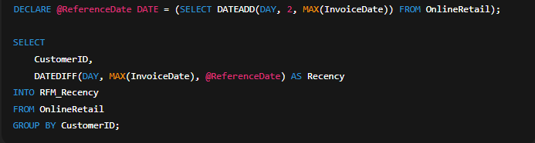
2️⃣ Frequency Calculation
This query counts how many unique invoices each customer has generated.
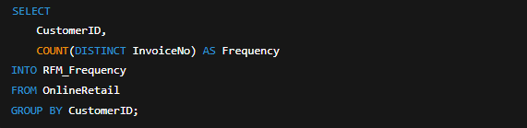
3️⃣ Monetary Calculation
The total amount spent by each customer (Quantity × UnitPrice) is summed up.
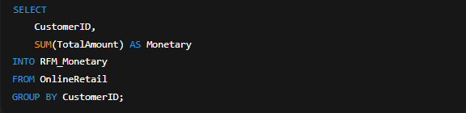

Finally, the three resulting tables are merged into one unified RFM table:
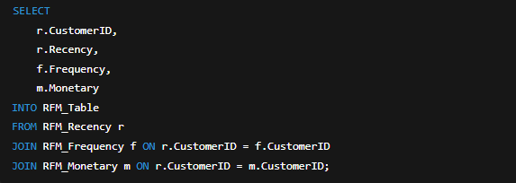
This consolidated table now contains all three RFM metrics for each unique customer.
4.4 Customer Segmentation Queries
After obtaining RFM values, customers were segmented by assigning RFM scores.
Each metric was ranked on a scale of 1 to 5 using the NTILE() window function.
RFM Scoring:
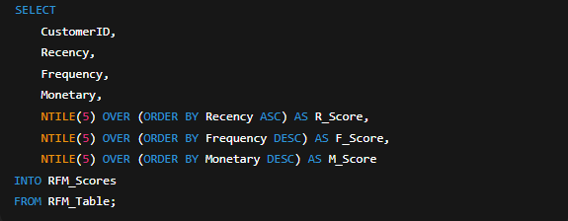
Each customer's three scores were then combined into a single RFM Score value:
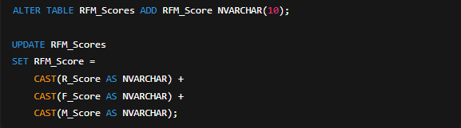
For example, a score of “555” represents the most valuable customers — frequent, high-spending, and recently active —
whereas “111” represents inactive or low-value customers.

5 Workflow of SQL Operations
The SQL operations followed a systematic workflow:
- Importing cleaned data from Python into SQL Server.
- Running validation checks for missing or invalid records.
- Calculating Recency, Frequency, and Monetary values.
- Assigning RFM scores and generating the unified RFM table.
- Creating customer segments based on combined RFM scores.
This workflow ensured data accuracy, analytical speed, and reproducibility.
The SQL environment provided the performance needed to efficiently process large volumes of customer data.
4.6 Importance of SQL in the Process
In data analytics workflows, Python provides flexibility for data wrangling and modeling,
while SQL ensures performance, scalability, and structure for querying large datasets.
In this project, SQL played a central role in:
- Performing RFM computations efficiently over hundreds of thousands of records.
- Allowing direct storage of analytical results in the database.
- Enabling real-time updates and future segmentation expansions.
The combination of Python and SQL provided a seamless analytical ecosystem where data preparation, computation, and segmentation were tightly integrated.
Ultimately, SQL formed the analytical backbone of this project, setting the stage for the next section — RFM Analysis and Segmentation.
5. RFM ANALYSIS AND SEGMENTATION
5.1 Understanding Recency, Frequency, and Monetary Metrics
The RFM model is one of the most effective analytical methods for understanding customer behavior.
It is based on three core metrics that reflect the customer’s interaction and value to a business:
- Recency: How recently a customer made their last purchase.
A lower recency value means the customer purchased recently and is still active, whereas a higher value indicates long inactivity.
- Frequency: How often the customer makes purchases within a specific period.
Customers with higher frequency are more engaged and typically form the loyal customer base.
- Monetary: The total amount of money spent by the customer within the observed period.
It directly represents the customer’s financial contribution to the business.
Combining these three variables makes it possible to assess each customer’s overall value to the company. The strength of RFM lies in its simplicity and interpretability — the metrics are easy to compute and provide actionable insights.
RFM analysis does more than summarize past behavior; it offers predictive insights into future tendencies:
- Customers with low Recency, high Frequency, and high Monetary values are the most valuable and active ones.
- Customers with high Recency but low Frequency are at risk of churn.
- Customers with high Frequency but low Monetary values represent consistent but low-spending buyers.
This combination allows marketing teams to identify which customers deserve retention efforts and which require reactivation campaigns.

5.2 Calculating RFM Scores
After computing the Recency, Frequency, and Monetary values in SQL, each metric was assigned a score ranging from 1 to 5.
This scoring process used the NTILE(5) function, dividing each metric into five equal groups based on distribution.
- Recency: Lower values (more recent activity) received higher scores.
- Frequency: Higher purchase counts received higher scores.
- Monetary: Customers with higher total spending received higher scores.
Each metric was then combined into a single three-digit code representing the RFM Score.
For example:
- “555” → the most valuable, frequent, and recently active customers.
- “111” → the least valuable, inactive, and low-spending customers.

SQL scoring query:
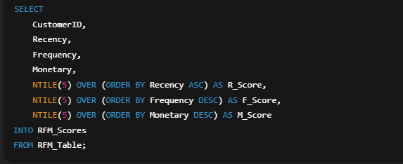
Combining the three individual scores into a single column:
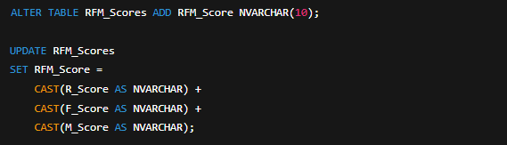
This step enabled each customer to be ranked based on their behavioral value in a simple yet powerful numeric format.
5.3 Defining Customer Segments
Once RFM scores were created, customers were grouped into value-based segments.
Segmentation helps marketing teams target specific customer categories more effectively and tailor communication strategies accordingly.
This project used eight commonly recognized RFM segments:
Segment Name | Description | RFM Characteristics
Champions | The best customers — recent, frequent, and high spenders. | R: 4–5, F: 4–5, M: 4–5
Loyal Customers | Regular and consistent buyers who drive stable revenue. | F: 4–5
Potential Loyalists | Newly acquired but already showing frequent activity. | R: 4–5, F: 3–4
New Customers | Recently made their first purchase. | R: 5, F: 1–2
Promising | New customers with increasing spending potential. | R: 4, F: 2–3
At Risk | Haven’t purchased recently, may be about to churn. | R: 2–3, F: 2–3
Hibernating | Long inactive and low-engagement customers. | R: 1–2, F: 1–2
Lost | Completely inactive customers. | R: 1, F: 1

These segments were automatically assigned using a SQL CASE WHEN statement:
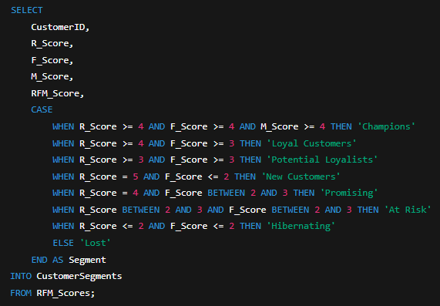
Each customer was then assigned to one of these eight categories based on their unique RFM pattern.
5.4 Interpreting RFM Results
The results of the RFM analysis revealed valuable insights into customer distribution and purchasing behavior.
In most real-world datasets, a small portion of customers (around 10–20%) falls into the “Champions” and “Loyal Customers” categories, yet this group often generates over 70–80% of total revenue — a pattern consistent with the Pareto principle (80/20 rule).
- Champions and Loyal Customers should be retained through loyalty programs, exclusive discounts, or membership campaigns.
- New Customers represent growth potential and should be nurtured through personalized onboarding campaigns.
- At Risk and Hibernating customers are prime candidates for reactivation campaigns.
- Lost customers typically require higher acquisition costs and may not be worth re-targeting.
These insights are essential for Customer Relationship Management (CRM), personalized marketing, and strategic decision-making.
Furthermore, RFM segmentation serves as a foundation for advanced analytical models such as Customer Lifetime Value (CLV) prediction and churn analysis.
This makes RFM not only a descriptive tool but also a bridge between traditional analytics and predictive modeling in business intelligence workflows.
- Power BI Visualization of RFM Analysis
At this stage, the RFM scores and customer segments calculated in SQL and Python environments were visualized using Power BI and transformed into a decision-support narrative. In this project, Power BI is not used as a calculation tool, but as a reporting and storytelling layer that presents analytical outputs in a clear, comparable, and interactive manner.
6.1 Data Sets Used
All datasets used in the Power BI dashboard consist of pre-calculated and aggregated outputs derived from the RFM analysis. These tables include segment-based revenue, order count, customer count, and average RFM metrics. The dashboard focuses solely on visualizing these finalized analytical results.
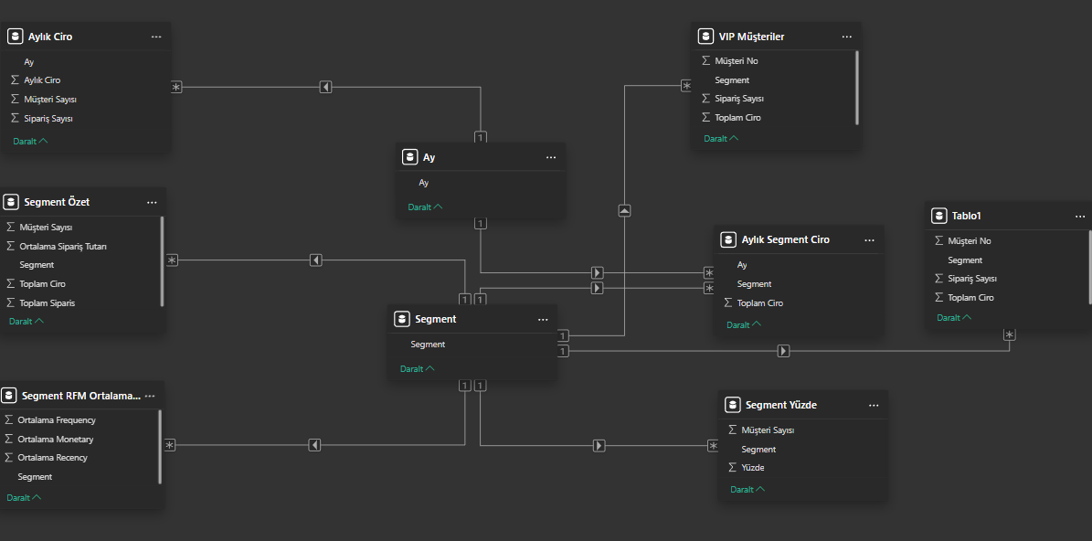
6.2 Key Takeaways from the Project
The dashboard is structured to support the analytical storyline and consists of the following main components:
- Overall Sales Performance:
The time-based trend of total revenue and order volume is presented to highlight overall sales dynamics.
- Segment-Based Comparisons:
Revenue and order contributions of customer segments are displayed using comparative charts.
- RFM Behavioral Indicators:
Average Recency, Frequency, and Monetary values are summarized using KPI cards and charts.
- Customer-Level Analysis:
High-value (VIP) customers can be analyzed in detail through customer-level tables.
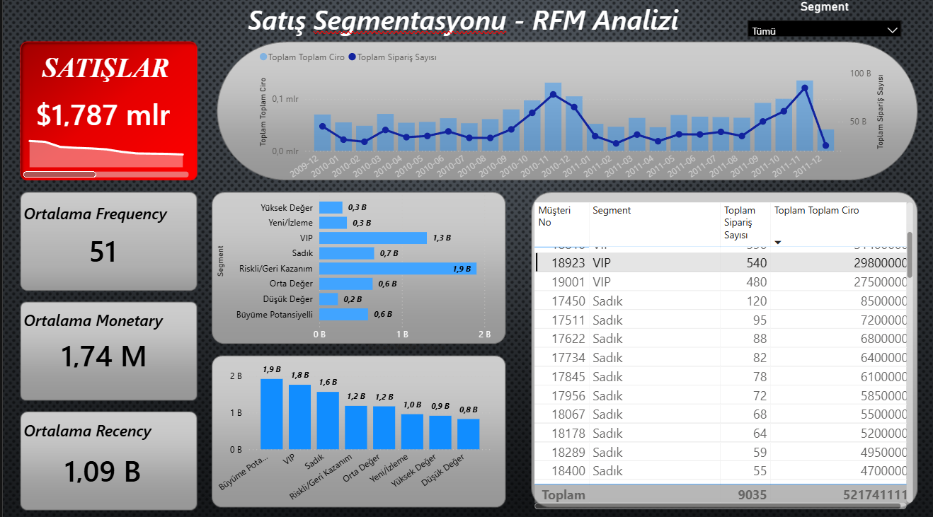
6.2 Business Insights
The Power BI dashboard enables:
- Clear identification of high-value customer segments and their contribution to total revenue,
- Rapid detection of at-risk or re-engagement segments,
- Segment-driven decision-making for marketing and customer management strategies.
This visualization layer transforms RFM analysis results into actionable and decision-oriented business insights for stakeholders.

7. REFERENCES
7.1 Dataset Source
- UCI Machine Learning Repository.
Online Retail II Dataset (2009–2011) — Department of Computer Science, University of California, Irvine.
Erişim: https://archive.ics.uci.edu/ml/datasets/Online+Retail+II
7.2 Academic References
- Fader, Peter S., Hardie, Bruce G. S., and Lee, Ka Lok (2005).
“RFM and CLV: Using Past Purchase Behavior to Predict Future Customer Value.”
Journal of Marketing Research, 42(4), 415–430.
- Khajvand, M., Zolfaghar, K., Ashoori, S., & Alizadeh, S. (2011).
“Estimating Customer Lifetime Value based on RFM Analysis of Customer Purchase Behavior: Case Study.”
Procedia Computer Science, 3, 57–63.
- Chen, Y. L., Kuo, M. H., Wu, S. Y., & Tang, K. (2009).
“Discovering Recency, Frequency, and Monetary (RFM) Sequential Patterns from Customers’ Purchasing Data.”
Electronic Commerce Research and Applications, 8(5), 241–251.
7.3 Technical References
- Python Software Foundation (2023).
Python Official Documentation.
Erişim: https://docs.python.org/3/
- Pandas Development Team (2023).
Pandas Library Documentation.
Erişim: https://pandas.pydata.org/docs/
- NumPy Developers (2023).
NumPy Documentation.
Erişim: https://numpy.org/doc/
- Microsoft SQL Server Documentation (2023).
Transact-SQL (T-SQL) Reference.
Erişim: https://learn.microsoft.com/en-us/sql/t-sql
7.4 Related Analytics Resources
- Kumar, V., Reinartz, W. (2018).
“Customer Relationship Management: Concept, Strategy, and Tools.”
Springer, 3rd Edition.
- Han, J., Kamber, M., & Pei, J. (2012).
“Data Mining: Concepts and Techniques.”
Elsevier, 3rd Edition.
- Larose, D. T. (2015).
“Discovering Knowledge in Data: An Introduction to Data Mining.”
John Wiley & Sons.
7.5 Additional References
- BTK Akademi (2024).
“Veri Bilimi için Python ve SQL Uygulamaları.”
E-Devlet onaylı eğitim programı.
- Kaggle (2024).
“Customer Segmentation Using RFM Analysis.”

